Which language would you l to use this site in?
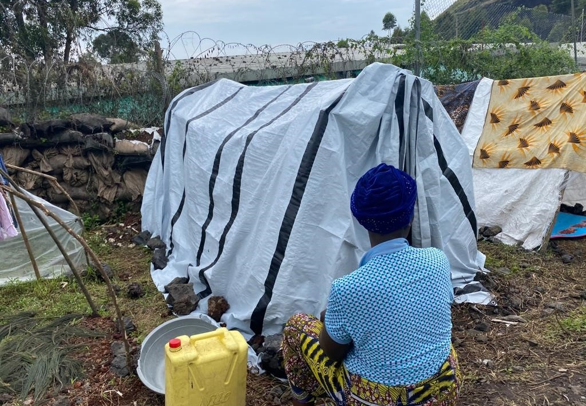Amnesty International, November 2022
NEWSFebruary 17, 2023

DR Congo: Rwandan-backed M23 rebels perpetrating summary killings and rapes.
- Rwandan-backed M23 rebels summarily killed men and raped dozens of women in eastern DRC late November 2022, investigation shows.
- This constitutes war crimes and could constitute crimes against humanity.
- Rape survivors and others attacked are yet to receive adequate assistance.
Members of the March 23 Movement (M23) rebel group killed at least twenty men and raped scores of women and girls in the eastern Democratic Republic of the Congo, an Amnesty International investigation released today reveals.
Survivors and other witnesses said that between 21-30 November 2022 fighters for the Rwandan- backed M23 group summarily killed at least 20 men and raped at least 66 women and girls, mainly in Kishishe, a small town located about 100km north of Goma, the capital of North-Kivu province.
Since these attacks survivors have been living in terror and utter destitution
Tigere Chagutah, Regional Director East and Southern Africa
The information gathered by Amnesty International appears to show these acts were part of a campaign waged by M23 to punish and humiliate civilians suspected of being supporters of rival armed groups, including the Democratic Forces for the Liberation of Rwanda (FDLR) and local Mai-Mai.
“Since these attacks survivors have been living in terror and utter destitution. While some rape survivors received basic medical attention from community health facilities most urgently need adequate medical and mental health care as well as humanitarian assistance,” said Tigere Chagutah, Amnesty International’s Regional Director for East and Southern Africa.
Survivors describe heinous attacks
Survivors and witnesses told Amnesty International that after taking control of Kishishe, groups of M23 fighters went house-to-house, summarily killing every adult male they found and subjecting scores of women to rape, including gang rape.
They said we were all FDLR. They singled out the men and shot them dead, including my husband and two sons.
Survivor, Kishishe, DRC
Aline* was raped by a group of men on 29 November 2022, along with six other women who were hiding in her house in the village of Kishishe.
She said: “They broke through the gate of the compound and rounded up all the men present, seven in total, who they killed. Five soldiers then raped us: six women and me. They called us FDLR wives.”
Eugenie* told Amnesty International that she was raped by three M23 soldiers on 30 November 2022 outside a church where she had sought refuge with her family following clashes between M23 and other armed groups.
“They said we were all FDLR. They singled out the men and shot them dead, including my husband and two sons. Three M23 soldiers then took me behind the church and took turns to rape me. I thought I would not survive.”
Another survivor who was raped outside the same church told Amnesty International that she counted scores of bodies of men who had been killed.
They took turns brutally raping me in the presence of my terrified little children.
Survivor, Kishishe,DRC
“I counted up to 80 bodies of men who had been shot dead by M23 soldiers at the church. I have never seen so many corpses in my life. I fainted before I could count all of them.”
Of the 13 survivors from Kishishe who said they were raped on 29 or 30 November 2022, 12 said their husbands or adult sons had been killed in cold blood.
Immaculée*, 23, was raped by two M23 soldiers. She told Amnesty International: “They took turns brutally raping me in the presence of my terrified little children. After raping me, they took all the valuables in the house and my two goats. We have found refuge, but we lack everything. We survive on the goodwill of the people who do not have much themselves. I have coped with rape, but I do not know if my children and myself will survive hunger.”
Lack of adequate medical care and humanitarian assistance
Most survivors interviewed by Amnesty International said they had received basic medical assistance from local health facilities including post-exposure prophylaxis (PEP) for sexually transmitted infections and received emergency contraceptives and painkillers. However, many said they were still suffering from persistent pain due to inadequate care, and there is no mental health support.
Mupenzi* was raped on 21 November in the town of Bambo after M23 soldiers summarily executed her husband.
“I reported to the health centre and received some painkillers, but I have been suffering from severe back pain and excruciating stomach pain. The head nurse at the health centre told me that there was nothing else they could do for me because they do not have the equipment and specialists.”
One health worker interviewed in mid-December 2022 said: “We lack everything from doctors to equipment and medical supplies. Even the PEP Kits are now exhausted with no prospect of replenishment. The situation is untenable.”
Justice and accountability
Days after the attack the Congolese authorities “strongly condemned the heinous crimes in Kishishe and Bambo” and promised to do everything they could to ensure justice. Nearly three months later there has been minimal progress.
“The DRC authorities’ failure to effectively investigate the allegations of patterns of summary killings, rapes, and other crimes under international law in relation to M23’s resurgence, and their inability to hold perpetrators to account, shows a complete contempt for victims,” Chagutah said.
The DRC is a party to several international and regional legal instruments which oblige states to prevent, investigate and prosecute those responsible for human rights abuses, and ensure comprehensive access to remedies for victims, including survivors of sexual violence.
DRC Authorities and international partners must hold perpetrators of such heinous crimes to account and serve justice to victims.
Tigere Chagutah
The scale and brutality of these mass rapes is particularly shocking. M23’s actions in the Kishishe area constitute war crimes and, to the extent that these rapes and murders are being committed by M23 as part of what appears to be a systematic attack on civilians perceived to be supportive of the FDLR and other armed groups hostile to M23, they should be investigated as possible crimes against humanity.
“DRC authorities with international support, including through the ongoing political processes led by the East African Community and the African Union, must hold perpetrators of such heinous crimes to account and serve justice to victims. They must urgently take all necessary steps to ensure that survivors of these crimes promptly receive adequate health care and humanitarian assistance.”
Background
In December 2022 and January 2023 Amnesty International gathered testimonies from 23 rape survivors and 12 eyewitnesses from the towns of Kishishe, Bambo Centre, and Bugina in interviews which were conducted individually on site in the local Swahili language. Amnesty International also reviewed medical records, official documents and interviewed government officials, UN representatives, and prominent humanitarian organizations about patterns of civilian killings and conflict-related sexual violence in the area.
The M23 group, which UN reports say is backed by Rwanda, claims to be fighting for the implementation of previous political agreements with the Congolese government, which provided for the safe return of Congolese Tutsi refugees who have been in Rwanda for two decades. It is also fighting the Democratic Forces for the Liberation of Rwanda (FDLR), a Rwandan rebel group that was established in eastern DRC in the aftermath of the 1994 genocide in Rwanda.
M23 has taken control of large territory in Nord-Kivu province, which borders Rwanda and Uganda, in the last year, driving half a million people to flee their homes according to the UN. Regional diplomatic efforts to stop its advance and disarm all armed groups in eastern DRC – known as the Nairobi process led by the East African Community, and the related Luanda process led by the African Union – have stalled.
*Names of witnesses have been changed to protect their identity

